Experiment 14: Common anode digital tube 8x8 dot matrix experiment
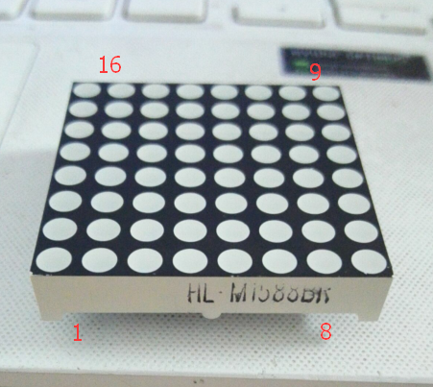

1.8*8 dot matrix diagram

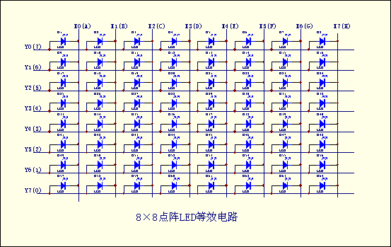

2.8*8 dot matrix physical map

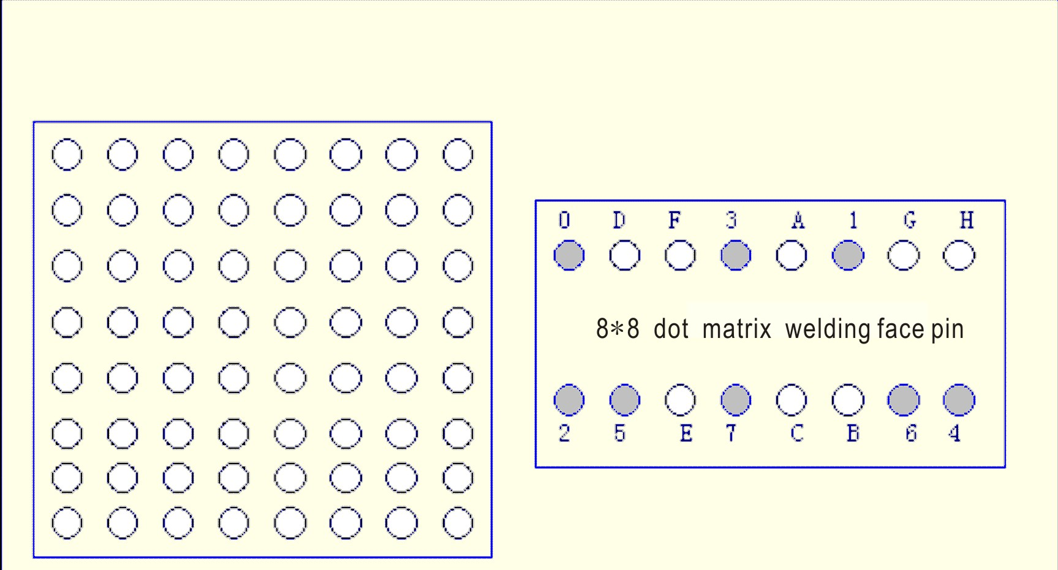

Figure 8 x 8 dot matrix LED appearance and pin diagram, its equivalent circuit as shown in figure (2), as long as its corresponding Y, X axis forward bias, you can make LED shine. For example, if you want to make the upper left corner LED lit, then X0=0, Y0=1 can be placed on the X axis or Y axis

3. 8*8 dot matrix scanning mode
LED generally use the scan type display, the actual use of three ways（1）spot scan
（2）Column scan
16 * 64=1024Hz period less than 1ms. If you use the second and the third way, frequency must be greater than 16 * 8=128Hz period less than 7.8ms conforming to the requirements of the persistence of vision. In addition a drive a column or row (eight LEDs) to an external driving circuit improves the current, otherwise LED light degree would be enough.
3. Examples of 8*8 dot matrix applications
Pin pin pin point when internal lattice structure and shape are as follows, 8x8 dot matrix consists of 64 light emitting diode, and each light emitting diode is placed in rows in line and column intersection, corresponding to a set level, a column set to zero level, the corresponding diode is bright; as to the first light, 9 high level 13 low level, the first point is bright; if the first line is light, the 9 feet meets high level, and 13,3,4,10,6,11,15,16 these pins low level. So the first line will be light to the first light column, 13 of the low level, and 9,14,8,12,1,7,2,5) to the high level, then the first column will be lit.
Generally we use the dot matrix display Chinese characters is a 16 * 16 dot matrix font font, the so-called 16 * 16, is each Chinese character in the longitudinal, cross each of the 16 points in the region show. That is to say with four 8 * 8 dot matrix into a 16 * 16 dot matrix. As shown in the following illustration, "you" is corresponding to light, because our lattice in the column is low level effectively, and the row line is active high, so to show "you" word, it bit code information to take anti, namely all columns (13 to 16 feet) send (1111011101111111,0xF7,0x7F ), and the first line (9 feet) to send a signal, then first send. Sending the second line to display data (13 to 16 feet) to send 1111011101111111,0xF7,0x7F, and the second line (14 feet) to send signal 1. By analogy, as long as each row of data shows that the time interval is short enough, to suspend the effects of the use of human vision, so send 16 times scanning data after 16, you will see a "you" word; the second kind of method of data sent is matrix signal sent to the line of the re scan the column is the same reason. Similarly to the word "you" to illustrate, 16 (9,14,8,12 , 1,7,2,5) send (0000000000000000,0x00,0x00) and the first column (13 feet) to send, "0". Similarly scanning the second column. When the line of sent 16 data column scanning the 16 times a "you" word is displayed the.
 |  |  | ● | ● | ●
 |  | ● |  |  |  | ●
 |  | ● |  |  |  | ●
 |  | ● |  |  |  | ●
 |  | ● |  |  |  | ●
 |  | ● |  |  |  | ●
 |  |  | ● | ● | ●
Therefore, formation of the column code to 00h, 00h, 3EH, 41h, 41h, 3EH, 00h, 00h; as long as the these codes are respectively sent to the corresponding column above, you can achieve "0" digital display.

Connection diagram of this experiment.
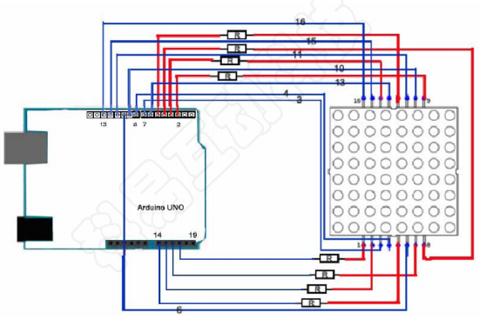
Components
- 1 * KUMAN Uno board
- 1 * Breadboard
- Jumper wires
- 8x8 dot matrix
- 8 * Resistor (220R)
- 1 * USB cable

Lit 8X8 dot matrix LED a LED as follows：
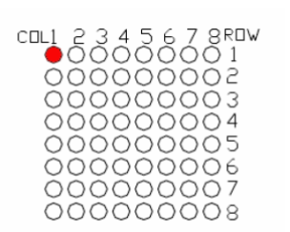

*******************************************************************************
Instance code:
//the pin to control ROW
const int row1 = 2; // the number of the row pin 9
const int row2 = 3; // the number of the row pin 14
const int row3 = 4; // the number of the row pin 8
const int row4 = 5; // the number of the row pin 12
const int row5 = 17; // the number of the row pin 1
const int row6 = 16; // the number of the row pin 7
const int row7 = 15; // the number of the row pin 2
const int row8 = 14; // the number of the row pin 5
//the pin to control COl
const int col1 = 6; // the number of the col pin 13
const int col2 = 7; // the number of the col pin 3
const int col3 = 8; // the number of the col pin 4
const int col4 = 9; // the number of the col pin 10
const int col5 = 10; // the number of the col pin 6
const int col6 = 11; // the number of the col pin 11
const int col7 = 12; // the number of the col pin 15
const int col8 = 13; // the number of the col pin 16
void setup(){
int i = 0 ;
for(i=2;i<18;i++)
{
pinMode(i, OUTPUT);
}
pinMode(row5, OUTPUT);
pinMode(row6, OUTPUT);
pinMode(row7, OUTPUT);
pinMode(row8, OUTPUT);
for(i=2;i<18;i++) {
digitalWrite(i, LOW);
}
digitalWrite(row5, LOW);
digitalWrite(row6, LOW);
digitalWrite(row7, LOW);
digitalWrite(row8, LOW);
}
void loop(){
int i;
//the row # 1 and col # 1 of the LEDs turn on
digitalWrite(row1, HIGH);
digitalWrite(row2, LOW);
digitalWrite(row3, LOW);
digitalWrite(row4, LOW);
digitalWrite(row5, LOW);
digitalWrite(row6, LOW);
digitalWrite(row7, LOW);
digitalWrite(row8, LOW);
digitalWrite(col1, LOW);
digitalWrite(col2, HIGH);
digitalWrite(col3, HIGH);
digitalWrite(col4, HIGH);
digitalWrite(col5, HIGH);
digitalWrite(col6, HIGH);
digitalWrite(col7, HIGH);
digitalWrite(col8, HIGH);
delay(1000);
//turn off all
for(i=2;i<18;i++) {
digitalWrite(i, LOW);
}
delay(1000);
}

***********************************************************************
The other experimental code is as follows:

Display A this letter, then the position in the dot matrix 1 through dynamic scanning display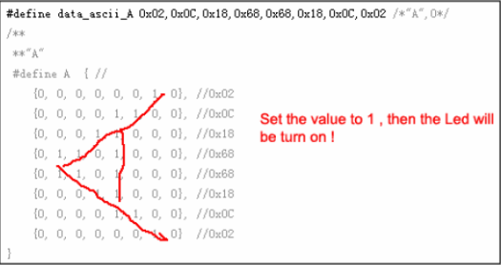
code：

#define display_array_size 8
// ascii 8x8 dot font
#define data_null 0x00, 0x00, 0x00, 0x00, 0x00, 0x00, 0x00, 0x00 // null char
#define data_ascii_A 0x02,0x0C,0x18,0x68,0x68,0x18,0x0C,0x02 /*"A",0*/
/**
**"A"
#define A { //
{0, 0, 0, 0, 0, 0, 1, 0}, //0x02
{0, 0, 0, 0, 1, 1, 0, 0}, //0x0C
{0, 0, 0, 1, 1, 0, 0, 0}, //0x18
{0, 1, 1, 0, 1, 0, 0, 0}, //0x68
{0, 1, 1, 0, 1, 0, 0, 0}, //0x68
{0, 0, 0, 1, 1, 0, 0, 0}, //0x18
{0, 0, 0, 0, 1, 1, 0, 0}, //0x0C
{0, 0, 0, 0, 0, 0, 1, 0} //0x02
}
**/
#define data_ascii_B 0x00,0x7E,0x52,0x52,0x52,0x52,0x2C,0x00 /*"B",1*/
#define data_ascii_C 0x00,0x3C,0x66,0x42,0x42,0x42,0x2C,0x00 /*"C",2*/
#define data_ascii_D 0x00,0x7E,0x42,0x42,0x42,0x66,0x3C,0x00 /*"D",3*/
#define data_ascii_E 0x00,0x7E,0x52,0x52,0x52,0x52,0x52,0x42 /*"E",4*/
#define data_ascii_F 0x00,0x7E,0x50,0x50,0x50,0x50,0x50,0x40 /*"F",5*/
#define data_ascii_G 0x00,0x3C,0x66,0x42,0x42,0x52,0x16,0x1E /*"G",6*/
#define data_ascii_H 0x00,0x7E,0x10,0x10,0x10,0x10,0x7E,0x00 /*"H",7*/
#define data_ascii_I 0x00,0x00,0x00,0x7E,0x00,0x00,0x00,0x00 /*"I",8*/
// display array
byte data_ascii[][display_array_size] = {
data_null,
data_ascii_A, data_ascii_B,
data_ascii_C,
data_ascii_D,
data_ascii_E,
data_ascii_F,
data_ascii_G,
data_ascii_H,
data_ascii_I,
};
//the pin to control ROW
const int row1 = 2; // the number of the row pin 24
const int row2 = 3; // the number of the row pin 23
const int row3 = 4; // the number of the row pin 22
const int row4 = 5; // the number of the row pin 21
const int row5 = 17; // the number of the row pin 4
const int row6 = 16; // the number of the row pin 3
const int row7 = 15; // the number of the row pin 2
const int row8 = 14; // the number of the row pin 1
//the pin to control COl
const int col1 = 6; // the number of the col pin 20
const int col2 = 7; // the number of the col pin 19
const int col3 = 8; // the number of the col pin 18
const int col4 = 9; // the number of the col pin 17
const int col5 = 10; // the number of the col pin 16
const int col6 = 11; // the number of the col pin 15
const int col7 = 12; // the number of the col pin 14
const int col8 = 13; // the number of the col pin 13

void displayNum(byte rowNum,int colNum)
{
int j;
byte temp = rowNum;
for(j=2;j<6;j++)
{
digitalWrite(j, LOW);
}
digitalWrite(row5, LOW);
digitalWrite(row6, LOW);
digitalWrite(row7, LOW);
digitalWrite(row8, LOW);
for(j=6;j<14;j++)
{
digitalWrite(j, HIGH); }
switch(colNum)
{
case 1: digitalWrite(col1, LOW); break;
case 2: digitalWrite(col2, LOW); break;
case 3: digitalWrite(col3, LOW); break;
case 4: digitalWrite(col4, LOW); break;
case 5: digitalWrite(col5, LOW); break;
case 6: digitalWrite(col6, LOW); break;
case 7: digitalWrite(col7, LOW); break;
case 8: digitalWrite(col8, LOW); break;
default: break;
}
for(j = 1 ;j < 9; j++)
{
temp = (0x80)&(temp) ;
if(temp==0)
{
temp = rowNum<<j;
continue;
}
switch(j)
{
case 1: digitalWrite(row1, HIGH); break;
case 2: digitalWrite(row2, HIGH); break;
case 3: digitalWrite(row3, HIGH); break;
case 4: digitalWrite(row4, HIGH); break;
case 5: digitalWrite(row5, HIGH); break;
case 6: digitalWrite(row6, HIGH); break;
case 7: digitalWrite(row7, HIGH); break;
case 8: digitalWrite(row8, HIGH); break;
default: break;
}
temp = rowNum<<j;
}
}

void setup(){
int i = 0 ;
for(i=2;i<18;i++)
{
pinMode(i, OUTPUT);
}

for(i=2;i<18;i++) {
digitalWrite(i, LOW);
}
}
void loop(){
int t1;
int l;
int arrage;
for(arrage=0;arrage<10;arrage++)
{
for(l=0;l<512;l++)
{
for(t1=0;t1<8;t1++)
{
displayNum(data_ascii[arrage][t1],(t1+1));
}
}
}
}

